|  |  |  |
| --- | --- | --- |
| **Kingdom of Saudi Arabia**  **Ministry of Education**  **King Khalid University** College of BusinessDepartment of Business Informatics |  | المملكة العربية السعوديةوزارة التعليمجامعة الملك خالدكلية الأعمالقسم المعلوماتية للأعمال |

**Title of the Project**

#### A report submitted in partial fulfillment of the requirements for the Graduation Project in XXXXXXX

## **by**

|  |  |
| --- | --- |
| **Student full name** | ***Student No.*** |
| **Student full name** | ***Student No.*** |
| **Student full name** | ***Student No.*** |
| **Student full name** | ***Student No.*** |
| **Student full name** | ***Student No.*** |

## Supervised by

**Dr./ XXXXXXXXXXX**

Academic Rank - Specialty

**2024 - First Semester**

1445/2023 © College of Business - Department of Business Informatics

|  |  |  |
| --- | --- | --- |
| **Kingdom of Saudi Arabia**  **Ministry of Education**  **King Khalid University** College of BusinessDepartment of Business Informatics |  | المملكة العربية السعوديةوزارة التعليمجامعة الملك خالدكلية الأعمالقسم المعلوماتية للأعمال |

**عنوان مشروع التخرج**

#### تقرير مشروع التخرج مقدم كمتطلب للحصول على درجة البكالوريوس في قسم ..........

## إعداد

|  |  |
| --- | --- |
| **الرقم الجامعي** | **اسم الطالب** |
| **الرقم الجامعي** | **اسم الطالب** |
| **الرقم الجامعي** | **اسم الطالب** |
| **الرقم الجامعي** | **اسم الطالب** |
| **الرقم الجامعي** | **اسم الطالب** |

## إشراف

**الدكتور /**

## الرتبة العلمية - التخصص

**6144هـ - الفصل الدراسي الأول**

6144/4202 © كلية الأعمال - قسم المعلوماتية للأعمال

|  |  |  |
| --- | --- | --- |
| **Contents** | | |
| Certificate from the Supervisor | | 5 |
| List of Figures | | 6 |
| List of tables | | 7 |
| Abstract | | 8 |
| **CHAPTER 1: Introduction** | | |
| 1-1 | Project problem in machine learning | 9 |
| 1-2 | Project objectives | 9 |
| 1-3 | Advantages and Disadvantages of Similar Models and Algorithms in Skin Care Recommendation Systems | 9-10 |
| 1-4 | Algorithms and techniques used | 10 |
| 1-5 | Work Methodology | 11 |
| 1-6 | The nature of the data used | 11 |
| **CHAPTER 2: Data cleaning and analysis** | | |
| 2-1 | Chapter introduction | 12 |
| 2-2 | Data preparation and cleaning | 12-13 |
| 2-3 | Exploratory data analysis (EDA) | 13-18 |
| 2-4 | Data preprocessing | 19 |
| 2-5 | Testing to ensure accurate evaluation of the model | 20- 21 |
| **CHAPTER 3: Building the machine learning model and the recommendation function** | | |
| 3-1 | Available algorithms | 22 |
| 3-2 | The most suitable algorithm | 23 |
| 3-3 | How KNN Works | 23 |
| 3-4 | Model building, training and the recommendation function | 24 |
| 3-5 | Recommending similar products | 25 |
| **CHAPTER 4: XXXXXXXXXXXXXXX** | | |
| 4-1 |  |  |
| 4-2 |  |  |
| 4-3 |  |  |
| 4-4 |  |  |
| 4-5 |  |  |
| **CHAPTER 5: XXXXXXXXXXXXXXX** | | |
| 5-1 |  |  |
| 5-2 |  |  |
| 5-3 |  |  |
| 5-4 |  |  |
| 5-5 |  |  |
| **CHAPTER 6: Conclusion and Future Works** | | |
| 6-1 |  |  |
| 6-2 |  |  |
| 6-3 |  |  |
| 6-4 |  |  |
| 6-5 |  |  |
| **References** | |  |
| **Appendix** | |  |
| **Arabic Abstract** | |  |

**CERTIFICATE**

This is to certify that the Project titled “XXXXXXXXXXXXX” was undertaken by

|  |  |
| --- | --- |
| **Student full name** | ***Student No.*** |
| **Student full name** | ***Student No.*** |
| **Student full name** | ***Student No.*** |
| **Student full name** | ***Student No.*** |
| **Student full name** | ***Student No.*** |

All chapter was prepared by all of the above-mentioned students, they all cooperated in implementing the Project, and the consolidated report was prepared by all of them under my supervision.

## Supervised by

**Dr./ XXXXXXXXXXX**

Academic Rank - Specialty

2024 - First Semester

|  |  |  |  |
| --- | --- | --- | --- |
| **List of Figures** | | | |
| **Figure** | **1-1** | Xxxxxxxxxxxxxxxxxxxx | xxx |
| **Figure** | **1-2** |  |  |
| **Figure** | **2-1** |  |  |
| **Figure** | **2-2** |  |  |
| **Figure** | **3-1** |  |  |
| **Figure** | **3-2** |  |  |

|  |  |  |  |
| --- | --- | --- | --- |
| **List of Tables** | | | |
| **Table** | **1-1** | xxxxxxxxxxxxxxxxxxxxxxxxxxxxxx | xxx |
| **Table** | **1-2** |  |  |
| **Table** | **2-1** |  |  |
| **Table** | **2-2** |  |  |
| **Table** | **3-1** |  |  |
| **Table** | **3-2** |  |  |

|  |
| --- |
| **Abstract** |

This project presents an innovative, data-driven solution to the common challenge of selecting the most suitable skincare products. By leveraging data analysis and user-centered design, the system empowers individuals to discover products tailored specifically to their skin type, concerns, and preferences. The goal is to enhance skincare routines through intelligent recommendations that not only improve skin health and appearance but also simplify the decision-making process. Through thoughtful research, algorithmic refinement, and a user-friendly interface, the project bridges the gap between consumer needs and product effectiveness—delivering a smart, personalized experience that translates into real-world impact.

|  |
| --- |
| **Chapter 1: Introduction** |

**1-1 Project problem in machine learning**

1- Many individuals struggle to choose the right skincare products to their skin type due to the variety of options and needs.

2- There is a need for a system that helps users select their skin type and receive appropriate product recommendations based on that selection.

3- The system helps reduce the time and effort spent searching for suitable products.

4- It improves the product selection process by helping users focus on products that are more likely to match their needs

**1-2 Project objectives**

1- Develop a prototype of an intelligent recommendation system that helps users select skincare products based on their skin type and ingredient preferences, using machine learning techniques

2- Utilize machine learning techniques to analyze data and generate intelligent product recommendations.

3- Improve user experience by providing accurate and reliable recommendations.

4- Minimize the effort and time required for users to make informed skincare decisions.

5- Achieve better skincare results by suggesting the most suitable products for each user.

**1-3 Advantages and Disadvantages of Similar Models and Algorithms in Skin Care Recommendation Systems**

**Advantages**

1- Personalizing recommendations and improving user experience:

- Recommendation systems provide a personalized experience for each user based on their skin type, purchasing history, and preferences.

- Increase user satisfaction by suggesting the products that are most suitable for them, leading to better purchasing decisions.

2- Big data analysis and pattern discovery:

-Machine learning models can analyze large amounts of data to extract specific consumption patterns for each skin type.

- This helps brands understand the market more deeply and target customers more accurately.

3- Improving product sales and increasing customer loyalty:

- Improving recommendations increases the likelihood that the user will purchase the suggested products, which boosts sales.

- These systems can enhance customer loyalty by providing them with a smart and convenient shopping experience.

**Disadvantages and Challenges**

1- Challenges of collecting and analyzing data:

- The recommendation system requires accurate and comprehensive data on users’ skin type, which may not always be available.

- There may be a lack of data for rare or sensitive skin types.

2- Unbalanced data problem:

- Some skin types may be unbalancedly represented in the data, leading to inaccurate recommendations for some categories.

3- Difficulty dealing with changing user preferences:

- User preferences may change over time due to factors such as changing seasons or changing skin type, which can make recommendations inaccurate if the data is not updated regularly.

**1-4 Algorithms and techniques used**

We used KNN, TF-IDF algorithms and techniques to analyze and filter the data, to build a recommendation model for skin care products.

**1-5 Work Methodology**

1st Phase: Data Exploration and Cleaning

- Clean data by removing missing values and correcting errors.

- Load data into Pandas Data Frame and analyze skin types and product categories.

2nd Phase: Recommendation Algorithm Selection

- Rule-Based Filtering: Filter products based on skin type

- Content-Based Filtering: Use techniques like TF-IDF to recommend similar products.

- Collaborative Filtering: Use KNN to suggest products based on user preferences.

3rd Phase: Model Building

- Train and test the recommendation model, optimize parameters.

4th Phase: System Evaluation

- Measure model performance using Precision, Recall, and F1-Score.

5th Phase: Deployment

- Create a simple interface for users to input their skin type and receive product recommendations via a web app (Streamlit or Flask).

**1-6 The nature of the data used**

**Data Nature:** The data will include text information on skincare products, such as product descriptions (including ingredients), user assessments (ratings and reviews), and data on skin types (e.g., oily, dry, sensitive, etc.).

**Data Source:** The data will be sourced from reputable e-commerce platforms or other online skincare retailers that provide access to product information, reviews, and skin type-related data.

**Data size:** It is expected that a large number of data ranges from hundreds or more, including records, to ensure the accuracy of the form and recommendations provided.

|  |
| --- |
| **Chapter 2: Data cleaning and analysis** |

**2-1 Chapter introduction**

This chapter covers data preparation, cleaning, analysis, and quality assurance, such as handling missing values ​​and removing duplicates. It also covers exploratory data analysis using statistical graphs or distribution analysis. It also includes preprocessing, such as converting data to a format suitable for the machine learning model, normalizing values, and converting them to numerical representations. It then validates the data with a training model to ensure the model's accuracy**.**

**2-2 Data preparation and cleaning**

**Import libraries: -**

- Pandas: Uses data and analysis, such as reading files, cleaning data, and analyzing them using data.

- matplotlib.pyplot: A library for windfall returns and charts for visualizing data.

- Seaborn: A library built on matplotlib that provides advanced methods for visualizing data and analyzing investor relationships in a more accessible way for investing.

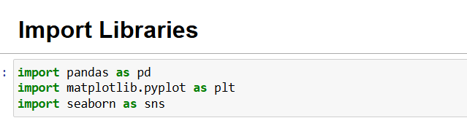

**- Load data:**  this code loads data from a CSV file into a DataFrame using the pandas library, a data frame similar to tables in Excel.

. It is used to display the first 4 rows of a DataFrame (df)

What is it for?

- Allows you to preview data after it has been loaded.

- Helps understand the structure of the table (such as column names and data types)

- Detects incorrect or missing data at the outset.

**2-3 Exploratory data analysis (EDA)**

- Detect missing values using df.isnull().sum().

- Replace missing values by filling empty values in the ingredients column with “No Info”. Replace empty values in the Price column with the median value for each brand. Replace empty values in the Rank column with the median value.

- Remove duplicates using df.drop_duplicates(). Remove any remaining empty rows using df.dropna(inplace=True).

Normalize numerical features (Price, Rank) using StandardScaler to make values -more consistent and reduce the impact of outliers.

- Analyze data visually by examining label distribution to identify the most popular product types.

The usefulness of charts in this analysis:

- Understanding the distribution of products by category (Label). The chart shows the number of products in each category, helping identify the most popular categories or those that need more focus in recommendations.

- The primary purpose of charts is to simplify complex data and make it easier to understand, discover patterns and trends that may not be apparent in tables, and conduct a comprehensive market and product analysis to improve recommendation strategies.

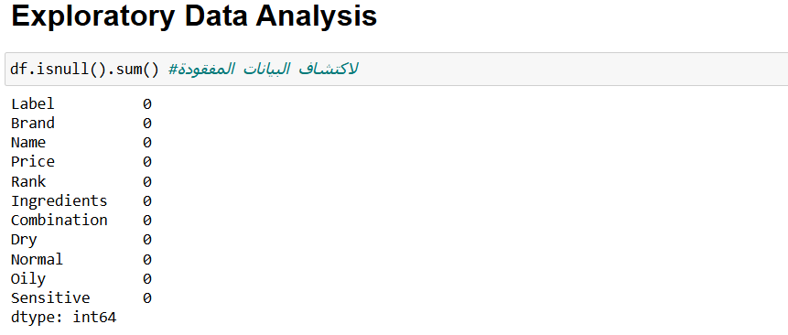

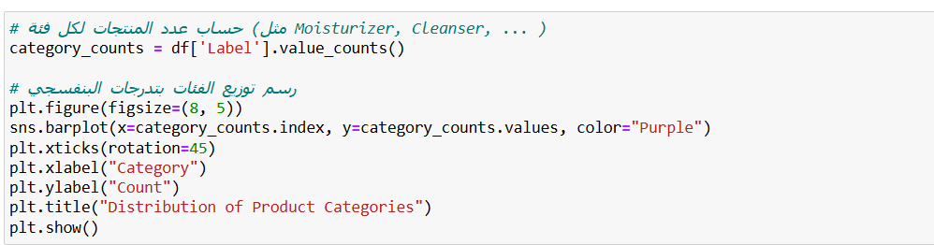

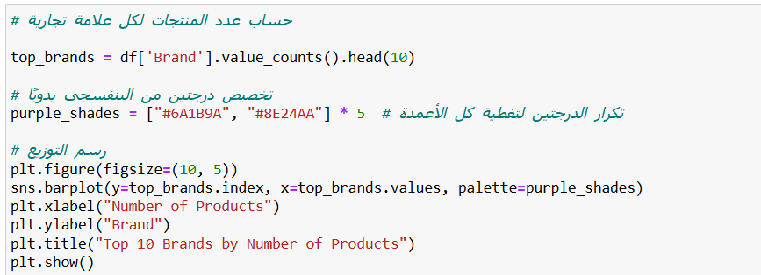

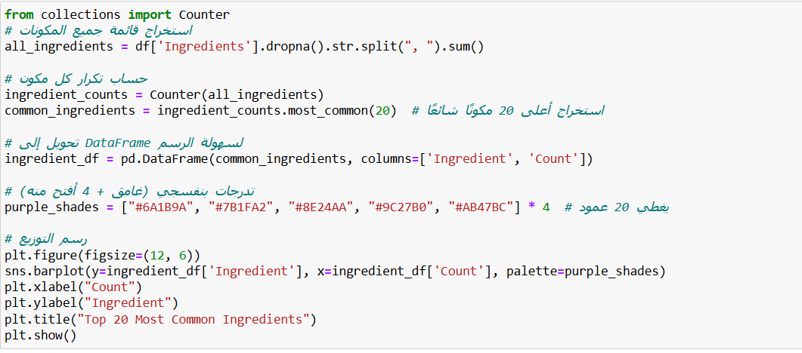

**2-4 Data preprocessing**

**- Converting components into numerical features using TF-IDF:**

The code demonstrates how to convert a list of ingredients into a numerical representation using the TF-IDF method, which is commonly employed in text processing and natural language processing tasks. The resulting TF-IDF matrix provides a structured way to analyze the importance of different ingredients across various documents, while also excluding common words that do not contribute significant meaning.

|  |
| --- |
| **Chapter 3: Building the machine learning model and the recommendation function** |

**3-1 The algorithm used**

- K-Nearest Neighbors (KNN):

Used to recommend skincare products based on skin type. The skin type was encoded numerically, and KNN was applied to suggest the closest products based on similarity in skin compatibility.

The KNN algorithm was used to suggest skincare products to the user based on their skin type.

The new user's data was compared with existing product data (categorized by skin type), and the products closest to their specifications were then filtered.

- Skin type was converted to numbers using Label Encoding.

- A KNN model was trained on this data to select the products closest to the user based on their skin type.

- The model returns a list of products that suit the user using kneighbors. In addition to KNN, several analytical functions were built that rely on data processing rather than machine learning. These are:

**3-2 Calculating Similarity Using Cosine Similarity**

Implemented to measure the similarity between products based on their ingredients using TF-IDF. This helped identify alternative products with similar formulations.

Cosine_similarity was used to measure the degree of similarity between products in terms of ingredients, after converting them to numerical representation using TF-IDF.

This function is used to identify products similar to a given product in terms of composition.

**3-3 Similarity Matrix Visualization**

A heatmap was generated to visualize the similarity between products based on their ingredients, helping to detect patterns and clusters.

**3-4 Cosine-Based and Jaccard Diversity**

Used to evaluate the variety of recommendations:

- Cosine-based diversity assessed the variation in ingredients:

Another function calculates diversity among products in recommendations but based on similarity of content (ingredients) rather than brand, and relies on the average cosine similarity within the group.

- Jaccard assessed brand diversity:

A function was developed to calculate the degree of brand diversity in recommendations using the Jaccard Index, with the aim of assessing the quality of recommendations in terms of diversity.

High diversity means that recommendations are not limited to a single brand, but rather include a diverse group.

**3-5 Relative Coverage**

Measured how widely each product connects to others in the dataset, indicating the system’s reach and comprehensiveness.

**3-6 Novelty Analysis**

Tracked how often each product appeared in recommendations. Less frequent items were considered more novel, reflecting the system’s ability to offer unique suggestions.

**3-7 Model building, training and the recommendation function**

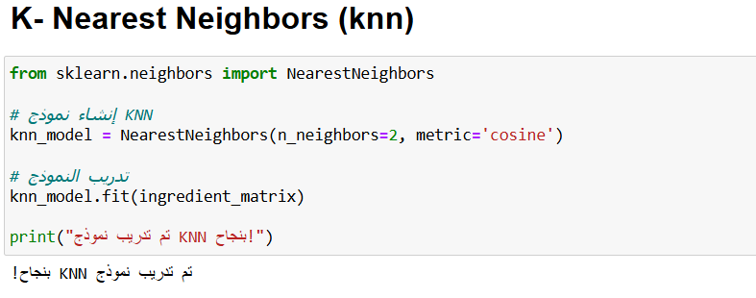

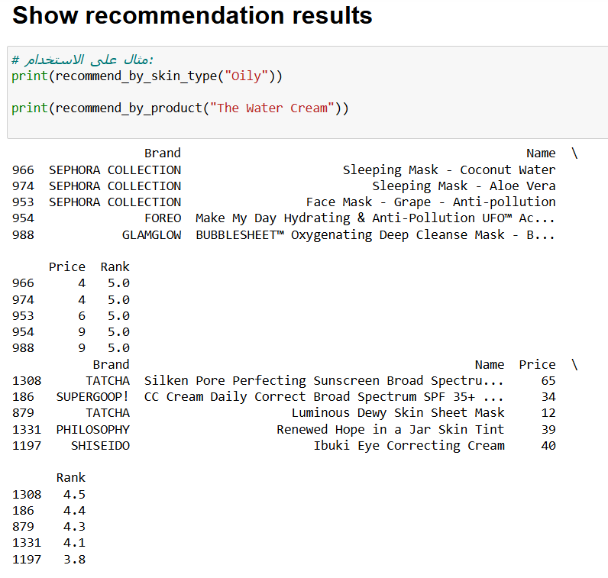

|  |
| --- |
| **Chapter 4: Model Evaluation** |

**4-1 Chapter Introduction**

In this chapter, the quality of recommendations produced by the system was evaluated using a set of analytical metrics implemented programmatically within the project.

The evaluation process focused on verifying the diversity of recommendations, their similarity in terms of ingredients, their comprehensiveness, and the average rating of the proposed products.

**4-2 Cosine Similarity**

To measure the similarity between the proposed products and a specific product in terms of active ingredients. Texts were converted to a numerical representation using TF-IDF, and similarity was calculated using Cosine Similarity. The closer the value is to 1, the more similar the proposed products are in their composition, enhancing the accuracy of the recommendation.

**4-3 Visualization of Similarity Matrix**

To visually inspect how products relate to one another based on ingredient similarity, a heatmap of cosine similarity scores was generated.

Each square in the matrix indicates the similarity between two products, with darker shades representing stronger relationships.

This visualization provided insights into product clusters and confirmed the logical consistency of the recommendation model.

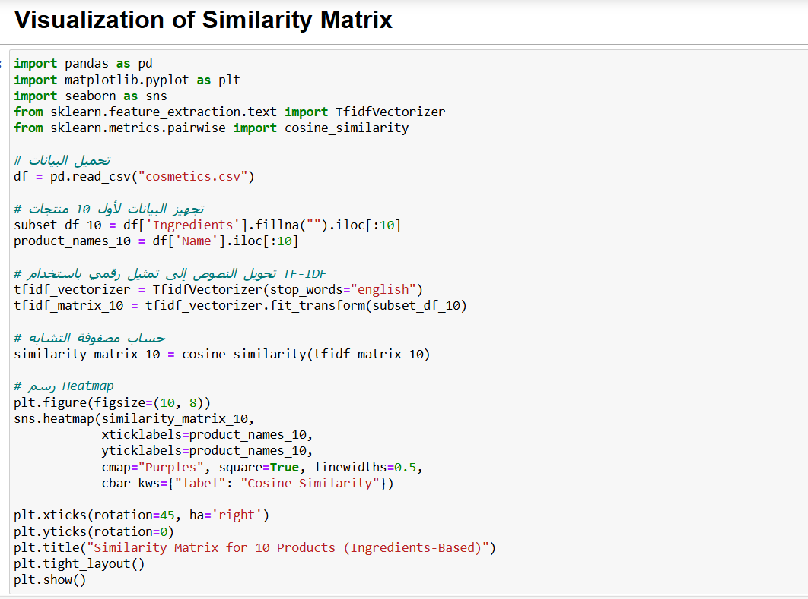

**4-4 Diversity**

To measure the variation among the recommended products, two approaches were applied:

- Cosine-based Diversity: focused on the variation in product ingredients, helping to avoid redundant recommendations that are too similar.

- Jaccard Diversity: was used to assess brand diversity, ensuring that the recommendations are not limited to a single brand.

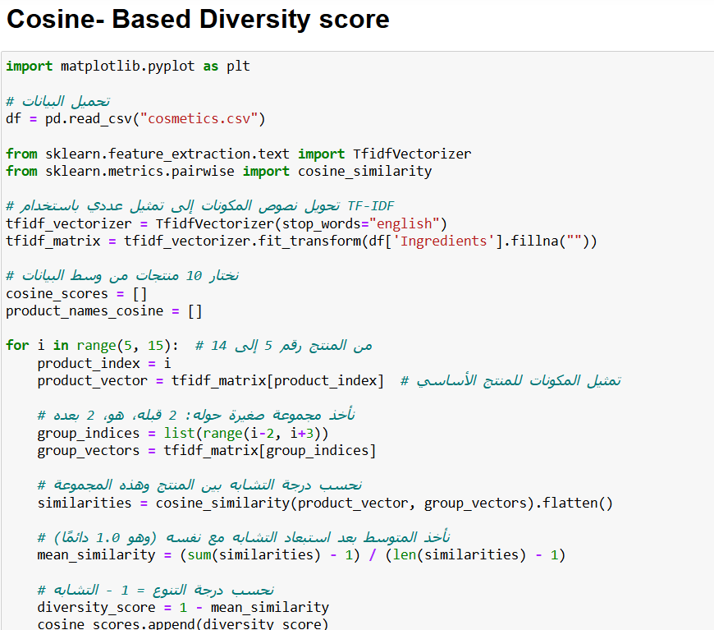

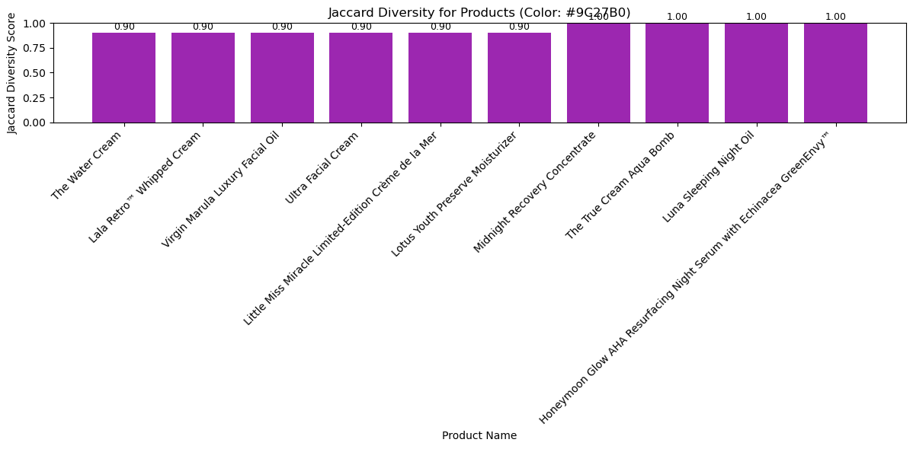

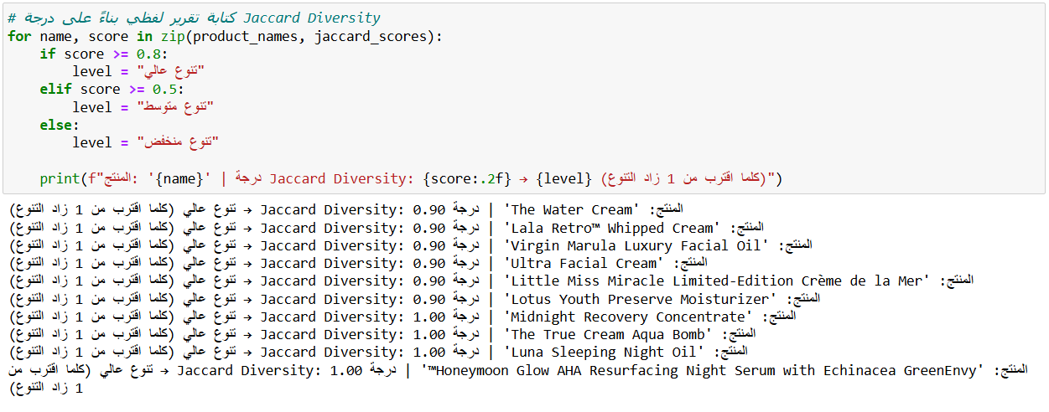

**4-5 Relative Coverage**

This metric evaluates how many other products in the dataset are similar enough to be recommended alongside a selected product.

It reflects the system’s reach and ability to connect a single product to a broader variety of alternatives, helping us understand how inclusive the recommendations are.

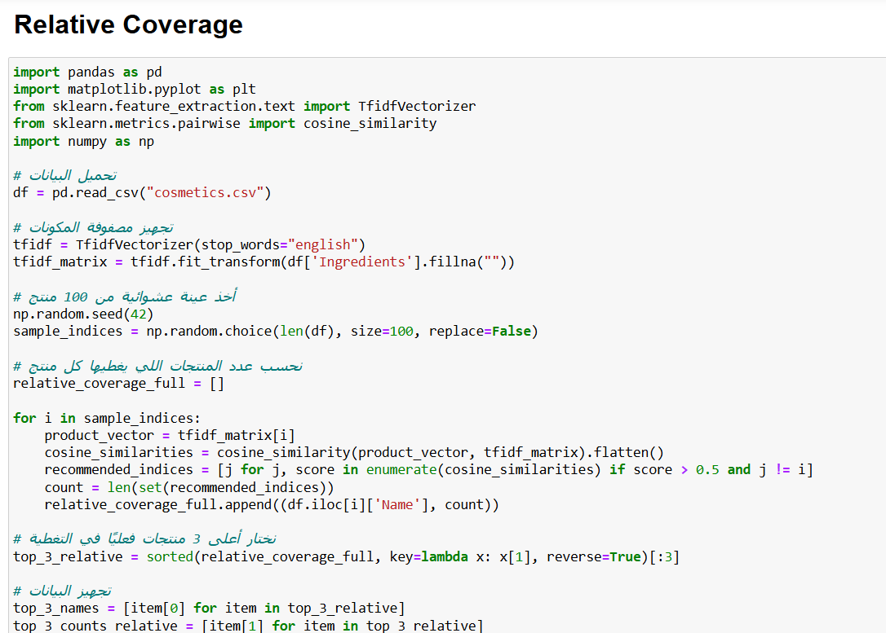

**4-6 Novelty**

This metric captures how often each product appears in recommendations.

Products that appear less frequently are considered more novel and can offer a refreshing experience to users by suggesting items they might not expect.

A bar chart was generated to illustrate the contrast between highly recommended (common) products and low-frequency (novel) ones, showcasing the system’s ability to balance between familiarity and discovery.

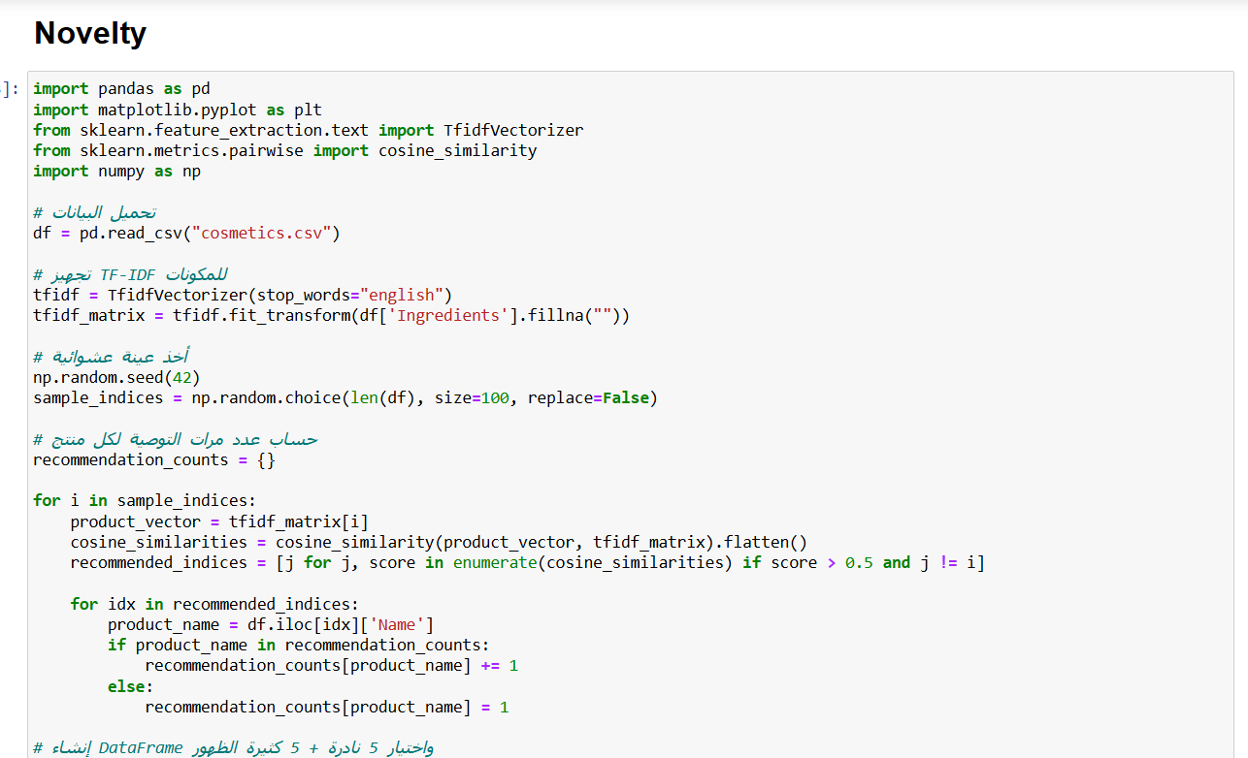

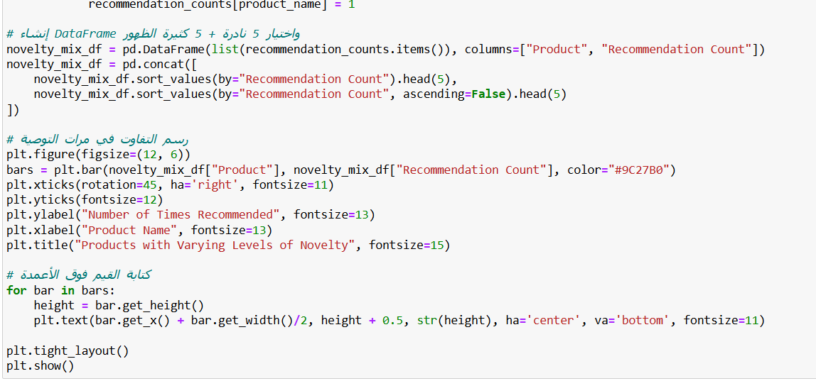

|  |
| --- |
| **Chapter 5: Model Deployment** |

**5-1 Chapter Introduction**

This chapter explains the process of deploying the recommendation model using a web-based interface. The deployment was implemented using Streamlit, a powerful and lightweight Python framework designed for building data-driven web applications. Streamlit allows users to interact with machine learning models and datasets in real time through intuitive widgets and responsive design.

**5-2 Objectives of Deployment**

The deployment aimed to:

- Provide users with an interactive interface to receive personalized beauty product recommendations.

- Enable users to filter products based on skin type, price, rating, and preferred ingredients.

- Enhance accessibility of the model, allowing real-time experimentation and usability through a simple browser.

**5-3 Interface Design and Layout**

The web interface was designed with a soft, pink-themed aesthetic to align with the beauty domain. The design includes:

- A gradient background using linear-gradient in CSS for a modern and elegant look.

- Stylized headers and buttons using custom fonts and colors imported from Google Fonts (Playfair Display).

- Interactive input widgets such as:

* + selectbox for selecting skin type
  + slider for price and rating ranges
  + text_input for entering ingredients
  + radio buttons for sort order

The entire layout is wrapped in a responsive navigation bar that allows switching between two main recommendation modes:

1- Skin Type Based Recommendation

2- Ingredient Based Recommendation

**5-4 Functionality of the Interface**

1- Skin Type Based Recommendation

Users can:

- Select their skin type (Oily, Dry, Normal, Combination, Sensitive).

- Filter the product list by specifying a price range and a minimum rating.

- Sort the results in ascending or descending order of price and rating.

- View recommended products with expandable panels that display the brand, name, price, and a visual rating using stars.

2- Ingredient Based Recommendation

Users can:

- Input ingredients manually (e.g., “niacinamide”, “vitamin C”).

- Receive product suggestions containing those ingredients.

- Apply the same filters as in the skin-based recommendation (price and rating).

- Get dynamic ingredient suggestions if the input ingredients are not found in the dataset.

Each feature is executed using efficient Pandas filtering operations and conditional logic, ensuring that the recommendations are tailored in real time based on user input.

**5-5 Interface Building Code**

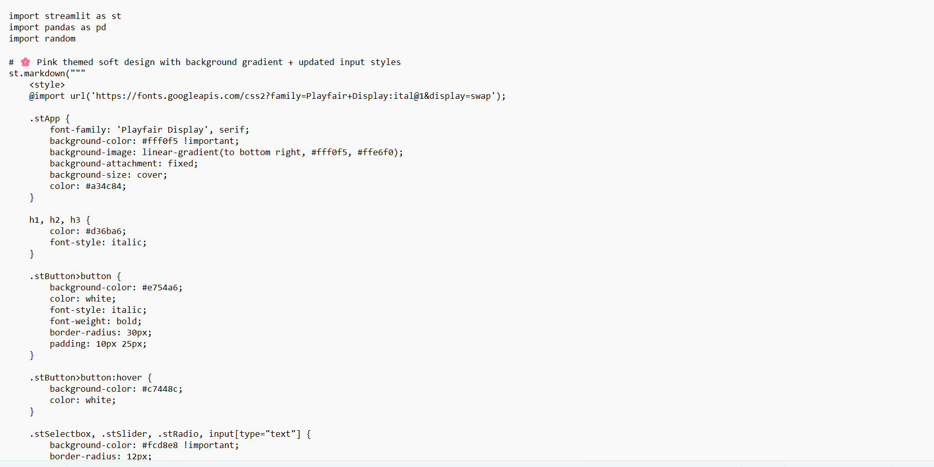

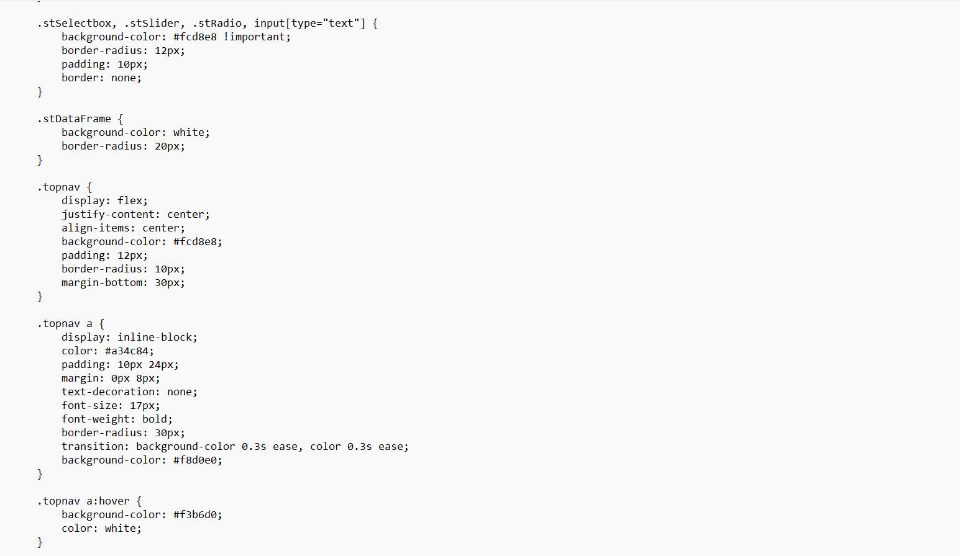

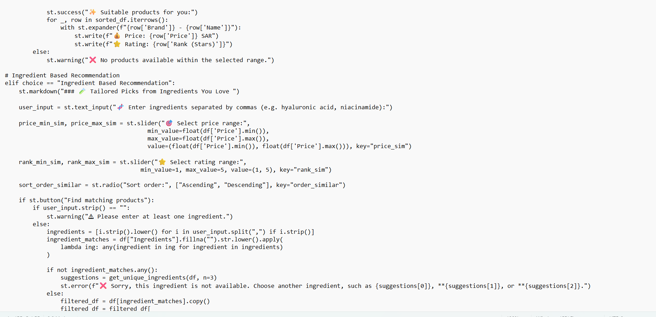

**5-6 The Interface**

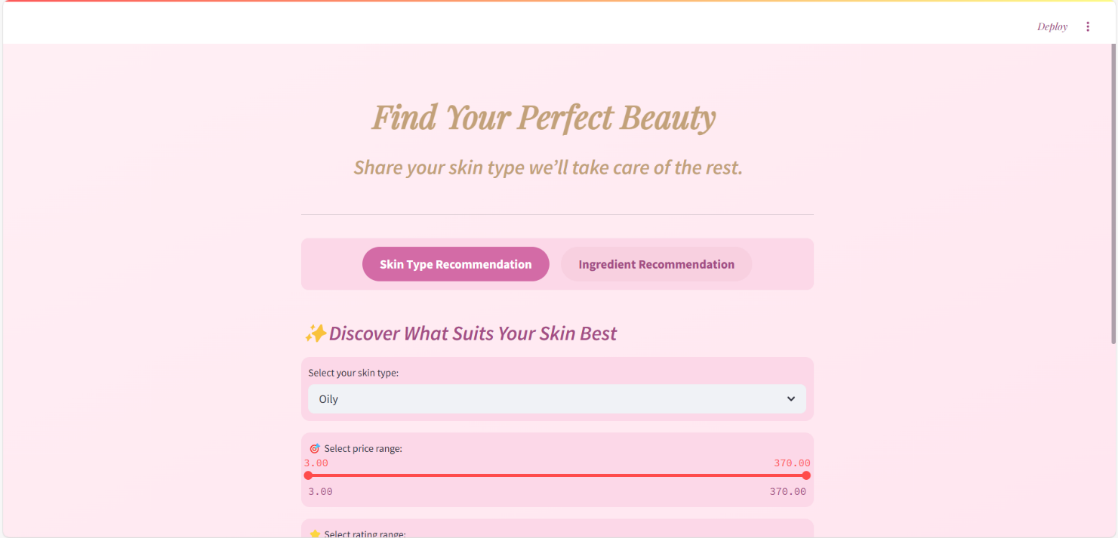

|  |
| --- |
| **Chapter 6: Conclusion and Future Works** |

**6-1 Final Results**

At the conclusion of this project, we successfully built an intelligent skincare product recommendation system based on the analysis of active ingredients in cosmetic products.

Key findings include:

- A comprehensive database was created containing a variety of skincare products, along with their properties and ingredients.

- A recommendation model based on ingredient similarity (cosine similarity) was implemented to provide accurate suggestions based on the ingredient selected by the user.

- The system allowed users to input a specific ingredient name, and in return, it generated a list of products that either contain that ingredient or have similar components.

• Several performance evaluation metrics were applied, such as:

• Average ingredient similarity (cosine similarity)

• Average rating of recommended products

• Diversity measurement of the recommendations

**6-2 Conclusion**

This project represents a practical and thoughtful approach to enhancing the skincare shopping experience through intelligent recommendations. By focusing on ingredient-based analysis, the system addresses a growing need for personalized and informed product selection—an area of increasing importance among users today. The accuracy, flexibility, and relevance of the results reflect the strength of the model and its alignment with real-world consumer expectations. With its solid foundation, the system holds great potential for future expansion into a more diverse and inclusive platform, capable of serving a broader range of user needs with even greater precision.

**6-3 Future Work**

While the system is capable of providing accurate and effective recommendations, there are future opportunities to develop and enhance it in multiple ways. One of the most notable expansions is the integration of "deep learning" techniques, such as using deep networks to analyze a user's skin image and generate recommendations based on its actual characteristics, which contributes to increased accuracy and personalization. Another proposal is to add an option that allows the user to exclude ingredients that may be harmful or allergenic, ensuring a safer experience that is more tailored to their individual needs. Furthermore, the system's capabilities can be expanded by applying classification algorithms to predict the most suitable skin type for each product. This will contribute to enhancing the efficiency of recommendations in the future and give the system greater ability to learn from labeled data. Together, these expansions represent a promising direction that can be added without compromising the quality of the current model, but rather serve as a solid foundation for building more advanced solutions.

|  |
| --- |
| **References** |

1- Kaggle – Cosmetics Dataset  
The primary dataset for this project was sourced from Kaggle. It contains detailed information on skincare products, including product name, brand, price, ingredients, and suitable skin type.  
Source link: <https://www.kaggle.com/datasets>

2- Scikit-learn Library Documentation  
The Scikit-learn library was used to implement the K-Nearest Neighbors (KNN) algorithm, as well as tools such as LabelEncoder, cosine_similarity, and TfidfVectorizer for text-based similarity analysis.  
Official documentation: <https://scikit-learn.org/stable/>

3- Pandas Library  
Pandas was used for loading, cleaning, and preparing the dataset for analysis—especially for handling columns, removing missing values, and filtering based on skin type or product name.  
Official documentation: <https://pandas.pydata.org/docs/>

4- Matplotlib Library  
Matplotlib was utilized to create visual representations such as diversity charts, price comparisons, and product similarity graphs.  
Official documentation: <https://matplotlib.org/stable/index.html>

5- Streamlit Documentation  
The final interactive web interface was built using Streamlit. It was used to design a user-friendly application that allows users to choose their skin type, view recommended products, and visualize data interactively.  
Official documentation: <https://docs.streamlit.io/>

|  |
| --- |
| **Appendix** |

|  |
| --- |
| الملخص |

**يتناول هذا المشروع تطوير نظام ذكي لتوصية منتجات العناية بالبشرة، يعتمد على تحليل البيانات وتعلم الآلة لتقديم توصيات مخصصة لكل مستخدم بناءً على نوع بشرته والمكونات المفضلة لديه. تم استخدام خوارزميات مثل KNN وTF-IDF لمعالجة البيانات وتحديد المنتجات الأنسب. كما تم تصميم واجهة تفاعلية باستخدام Streamlit تتيح للمستخدمين إدخال معلوماتهم واختيار المنتجات المناسبة بسهولة.**

**يساهم النظام في تحسين تجربة التسوق للعناية بالبشرة من خلال تقديم توصيات دقيقة وشخصية، وتقليل الوقت والجهد اللازمين لاتخاذ قرارات الشراء. كما يشمل المشروع تحليلات لتقييم أداء النموذج من حيث التنوع والدقة والحداثة.**

**وفي الختام، يمثل المشروع خطوة عملية نحو تطوير حلول ذكية وشخصية تخدم احتياجات المستخدمين في مجال العناية بالبشرة، مع إمكانيات واعدة للتوسعة المستقبلية باستخدام تقنيات أعمق مثل تعلم العمق وتحليل صور البشرة.**